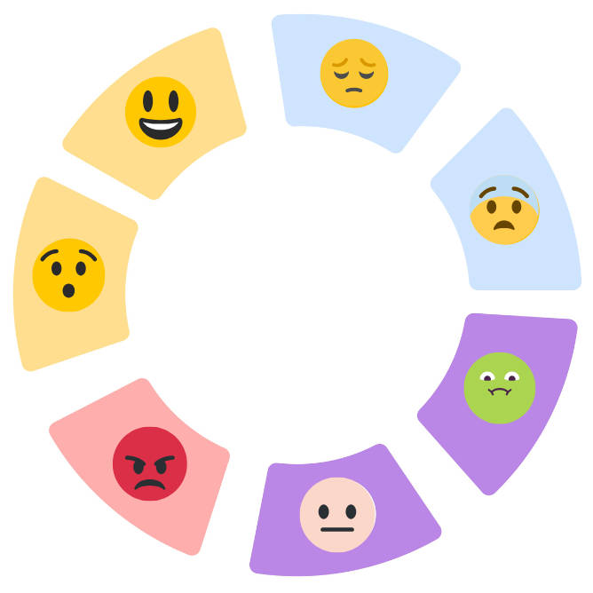

The Emotional Wheel and Workbook

A Guide to Understanding Our Feelings
Sometimes, our emotions feel like an overwhelming jumble of mixed thoughts, or maybe we've become so used to suppressing them that we don’t properly notice how we feel. That’s where the Emotional Wheel comes in: this guide will help you use it to recognise and name your feelings, and the accompanying workbook will help you explore them further.

Quick-Start Guide: How to Use the Wheel
If you want to get going straightaway and don’t want to read a lot of text, just follow these simple steps. For a more thorough understanding, read the full guide below.
- Step 1: Notice your body. Pay attention to what's happening inside you. Do you have a fast heartbeat? Are your muscles tightening? Are you feeling low in energy?
- Step 2: Check the Wheel. Look at the Emotion Wheel and see which of the broad categories best describes what you are experiencing right now: Happy, Sad, Surprised, Fearful, Disgusted, Bad, or Angry.
- Step 3: Name the emotion. Once you have a name for the feeling, such as 'sadness' or 'disgust,' simply allow the feeling to be there without judging it.
- Step 4: Ask yourself what you need. This simple check-in helps you move forward constructively.

Understanding Our Emotions: The Full Guide
Emotions are a fundamental part of being human, and gaining a better understanding of their purpose can help us use them as valuable helpers in our lives. When we learn to recognise our feelings, it's a powerful step towards managing and responding to our emotional experiences more effectively.

Why Do We Have Emotions?
A common myth is that there are 'good' and 'bad' emotions, but the truth is every human emotion is equally valuable and serves an important purpose.
Emotions are essential for a healthy life. They:
- Help us to communicate with others and serve as a form of communication to ourselves.
- Aid us in making decisions.
- Warn us of danger and signal an alarm that something is happening.
- Motivate us to get what we want or need.
- Get us ready for action in dangerous or urgent situations, so we can act quickly.
- Provide us with information.
- Help us do hard things and keep us going to overcome obstacles.
Some emotions, like sadness, fear, and anger, can be labelled 'tricky' or 'difficult,' not because they are always 'bad,' but because they come with thoughts and sensations that are unpleasant or painful to experience.

How to Recognise Our Emotions
The practice of managing and responding to our emotional experiences begins with simply noticing, naming, and describing how we're feeling in the present moment.
- Start with the body: Emotions are felt throughout our bodies. For example, we might experience muscle tightening when angry, fear might speed up our heartbeat or leave us breathless, and sadness might lead to crying and a feeling of being run down.
- Use the Emotion Wheel: The wheel provides categories to help us label and recognise what we're experiencing. This helps turn vague, overwhelming sensations into something concrete we can understand.
- Use the workbook for deeper insight: The workbook pages give space to explore what these emotions are like for us personally, and to reflect on the beliefs and thoughts attached to them. This practice can help us challenge common emotion myths, like believing negative feelings are destructive or that our emotions define who we are.

Using the Personal Practice Plan
The final pages of the workbook are designed to turn this understanding into regular, positive habits.
- Notice and Name: We can use the chart to track and name emotions experienced throughout the week, using the Emotion Wheel as a guide.
- Reflect on Our Experience: Record notes on when we did the work, how we felt while doing it, whether it was easy or difficult, and any barriers we encountered. This reflection will help us understand ourselves more deeply.
- No Right or Wrong: Don’t overthink the process; remember that this is a personal reflection; all experiences are welcome, and there are no right or wrong answers. Just give it a go.
Understanding our emotions gives us the power to transform them from unpredictable forces into partners we can draw upon when we need them most.

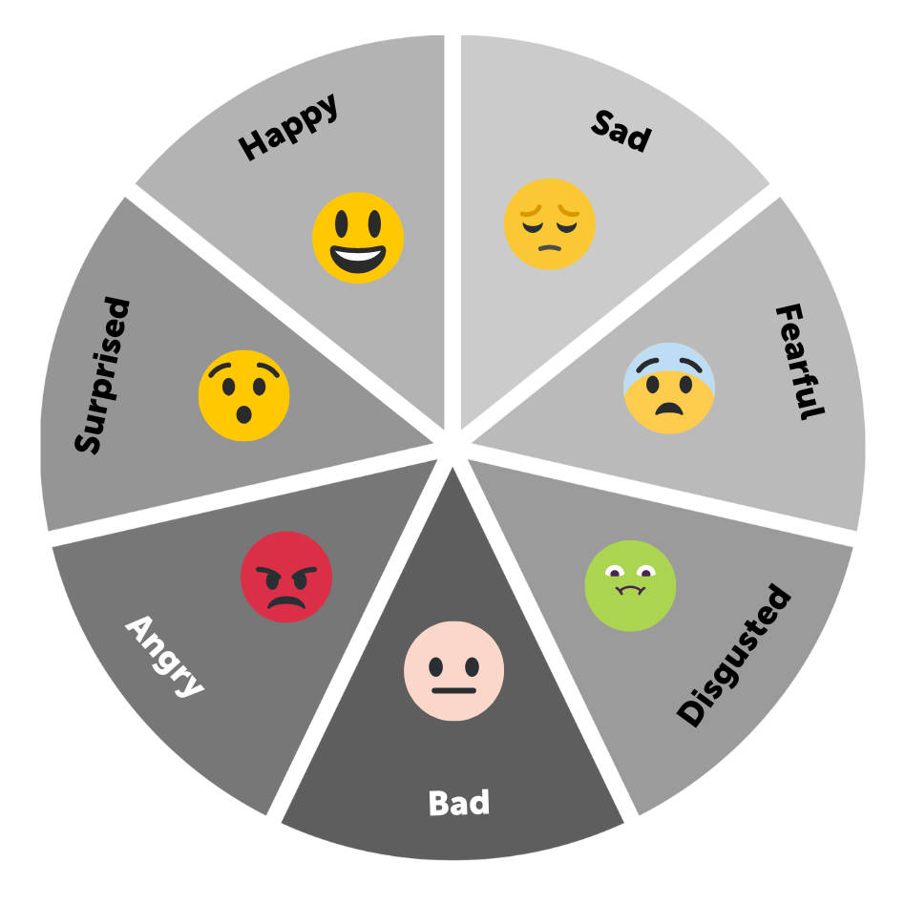


Emotion: Happy
 | Typical Examples: | What it is like for me:
Ways to Name this emotion:

Events that can/might cause this emotion:

Beliefs and Thoughts around this emotion:

How this feels in our body:

Actions that might follow:

What might happen after:


Emotion: Sad
 | Typical Examples: | What it is like for me:
Ways to Name this emotion:

Events that can/might cause this emotion:

Beliefs and Thoughts around this emotion:

How this feels in our body:

Actions that might follow:

What might happen after:


Emotion: Fearful
 | Typical Examples: | What it is like for me:
Ways to Name this emotion:

Events that can/might cause this emotion:

Beliefs and Thoughts around this emotion:

How this feels in our body:

Actions that might follow:

What might happen after:


Emotion: Disgusted
 | Typical Examples: | What it is like for me:
Ways to Name this emotion:

Events that can/might cause this emotion:

Beliefs and Thoughts around this emotion:

How this feels in our body:

Actions that might follow:

What might happen after:


Emotion: Bad
 | Typical Examples: | What it is like for me:
Ways to Name this emotion:

Events that can/might cause this emotion:

Beliefs and Thoughts around this emotion:

How this feels in our body:

Actions that might follow:

What might happen after:


Emotion: Angry
 | Typical Examples: | What it is like for me:
Ways to Name this emotion:

Events that can/might cause this emotion:

Beliefs and Thoughts around this emotion:

How this feels in our body:

Actions that might follow:

What might happen after:


Emotion: Surprised
 | Typical Examples: | What it is like for me:
Ways to Name this emotion:

Events that can/might cause this emotion:

Beliefs and Thoughts around this emotion:

How this feels in our body:

Actions that might follow:

What might happen after:

